2/3/2022

Qureshi Azeem

University College Birmingham

Website Logbook

Made by Azeem Qureshi

This is where we are going to show out development process of our website

# Logbook

3/2/2022

I have previously designed websites by creating a design which I consider to follow through. This allows me to have a strong idea where I’m going with this website. Such as having a logo in the top right corner as well as having buttons at the top of the page rather than having a sidebar, all whilst continuously keep a nice page aesthetic. But for this website I have decided to keep

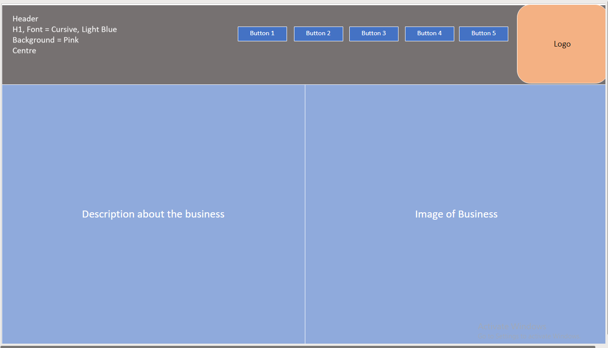

Here on this page of the website, I will be displaying all of my client’s services and how much they cost. This is to allow people who are planning to become customers have a good idea of how much everything’s costs and what they want their child to learn.

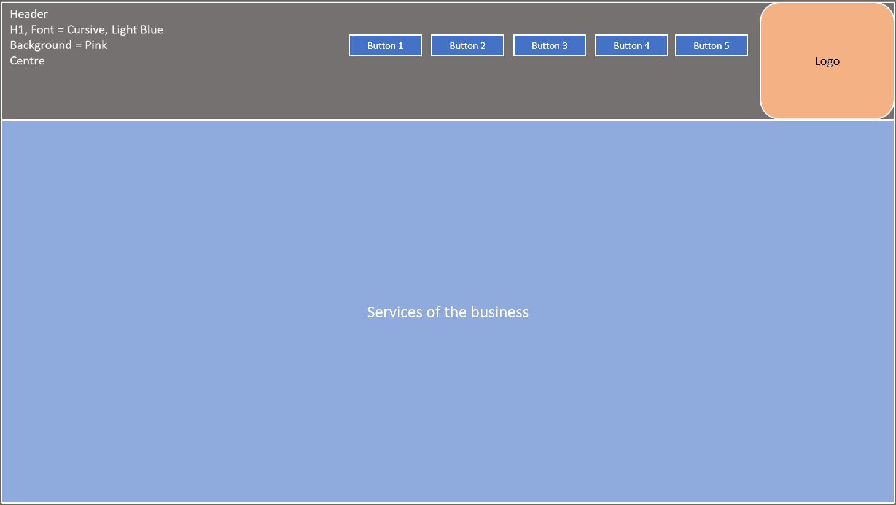

On this page of the website, here is where people are going to be able to contact us (The owner). Thus allowing the users to have peace of mind since they will be able to have all of their questions answered

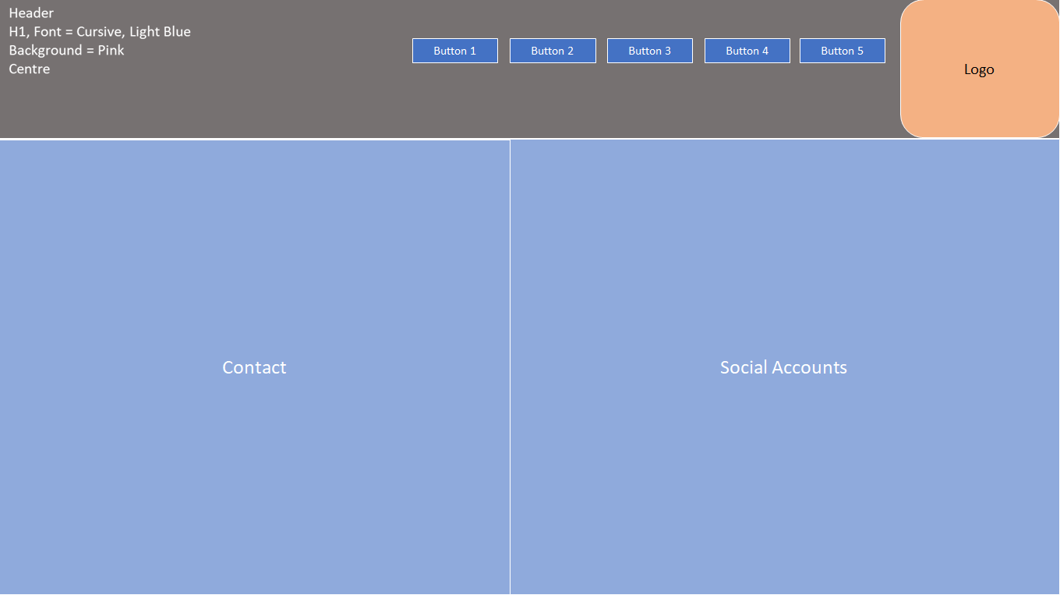

On this page here is where people will be able to book the services that they want. Allowing them to easily be able to book the services they need or want, since they wouldn’t have to call up/contact the owner of the business

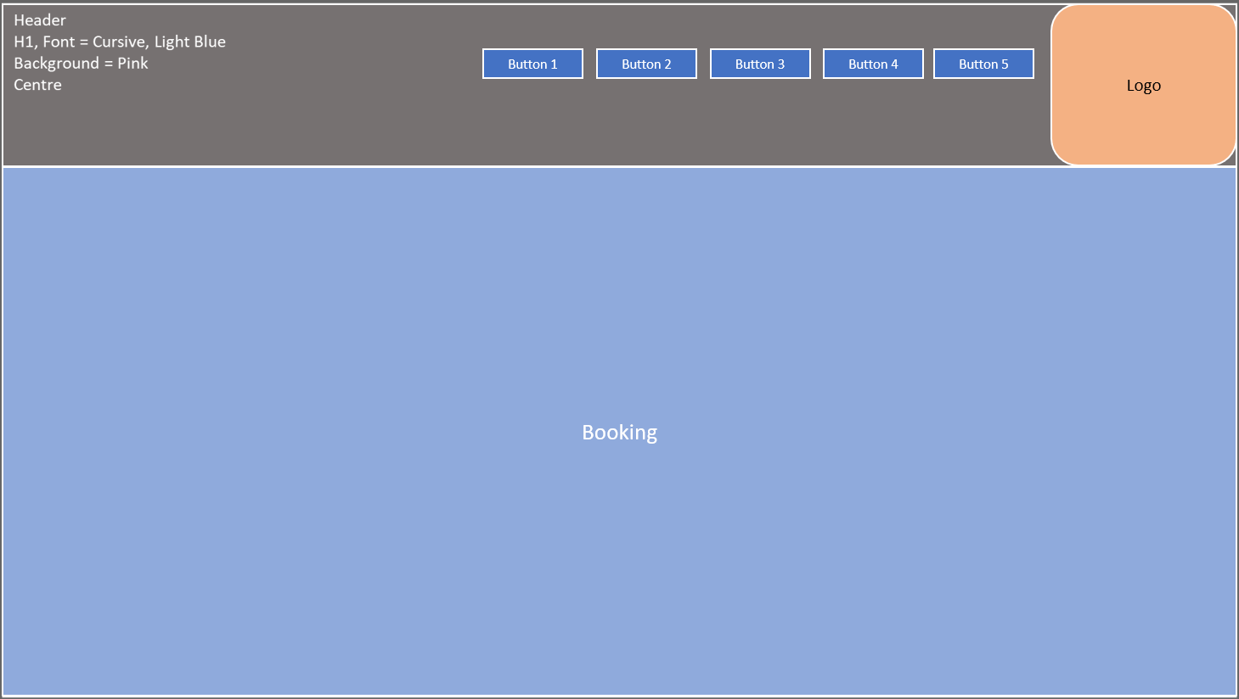

Finally here is where I’ll put adding the Form. Forms are normally used to collect the required information in a logical, meaningful fashion for communication. This allows the business to contact the individual in-case anything has gone wrong with booking/services or give information about changes that may be happening overall.

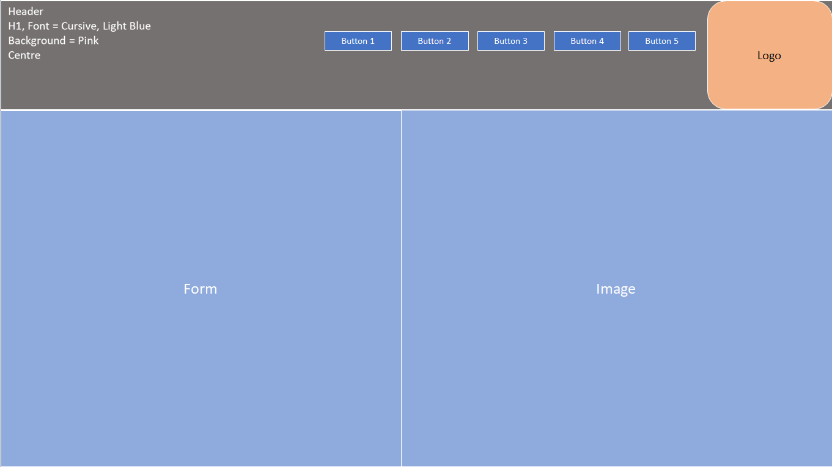

20/2/2022

Ι designed my second webpage and gave it a colour scheme that I will use to start off and then when I’m finally done finishing the website, I will most likely change it because it may need to look neater after all the development is finished

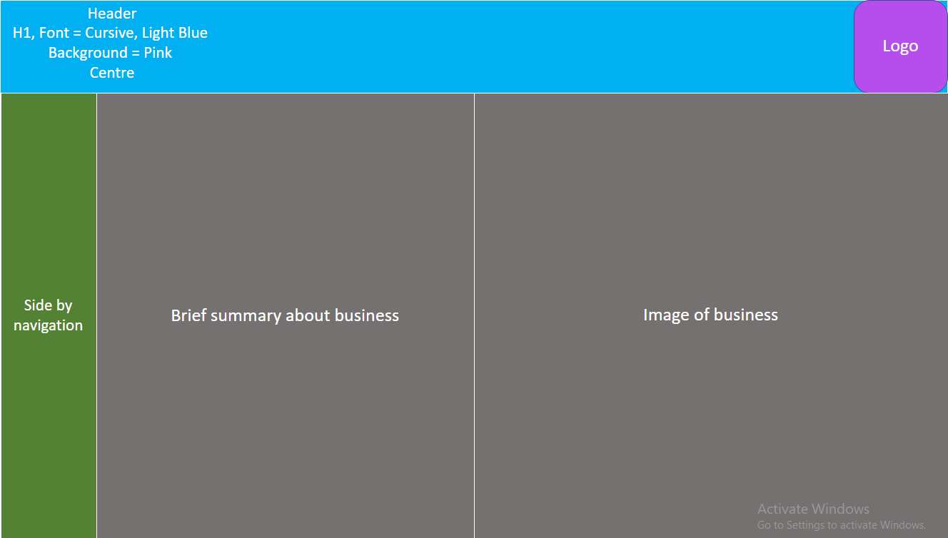

# Redesigning my website – Page 1

## Old Design + Showing Error

I have redesigned my website from looking like this; this was my original idea to have a wavy pattern.

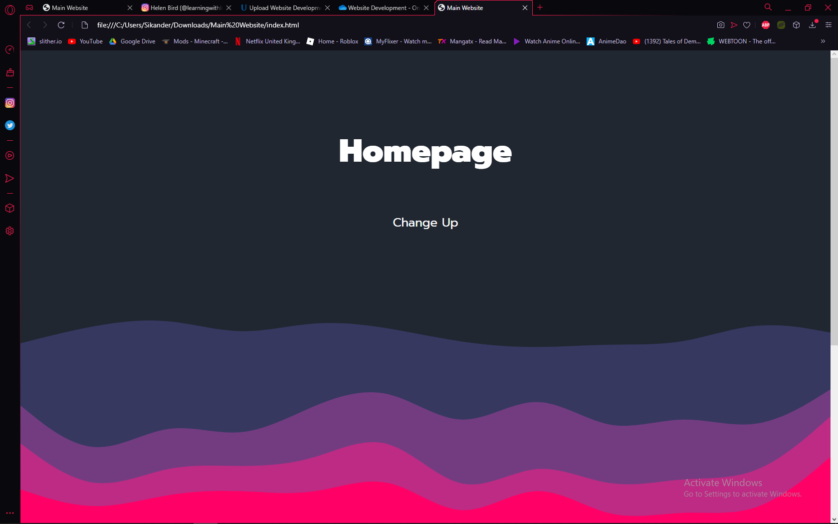

## New Design

So I redesigned my new page to have a new look, using a HTML5 style. My new page will have a clean look with animations that fade in from the side when you scroll down the page.

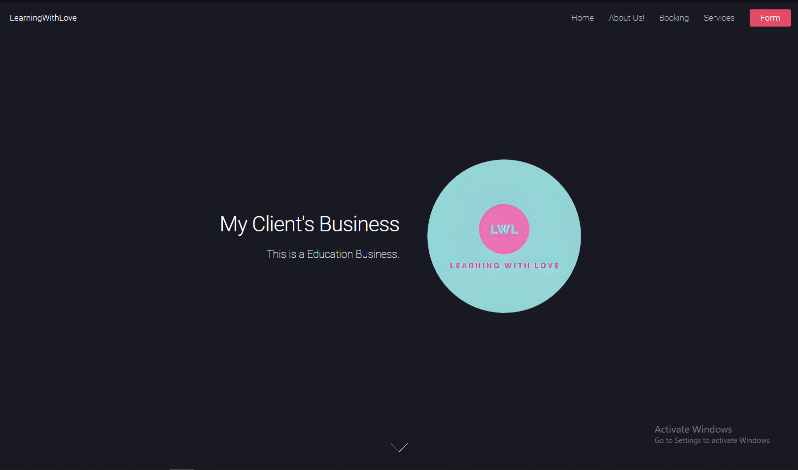

# Introduction

## Purpose of the website

To provide my audience with a website where they can inquire, and see what the business is about whilst also knowing what the services cost.

## Target Audience

This business targets the parents of children who want to get their children in education,

## Planning

## Mood Board

# Error

## First Error

I realised that it never worked out because I would always get an error when I try to move my css, to my stylesheet.css file.



The result would turn out to be this. This made me realise that the blob animation style that I had put in using js (JavaScript), would not work out so I decided to redesign my website.

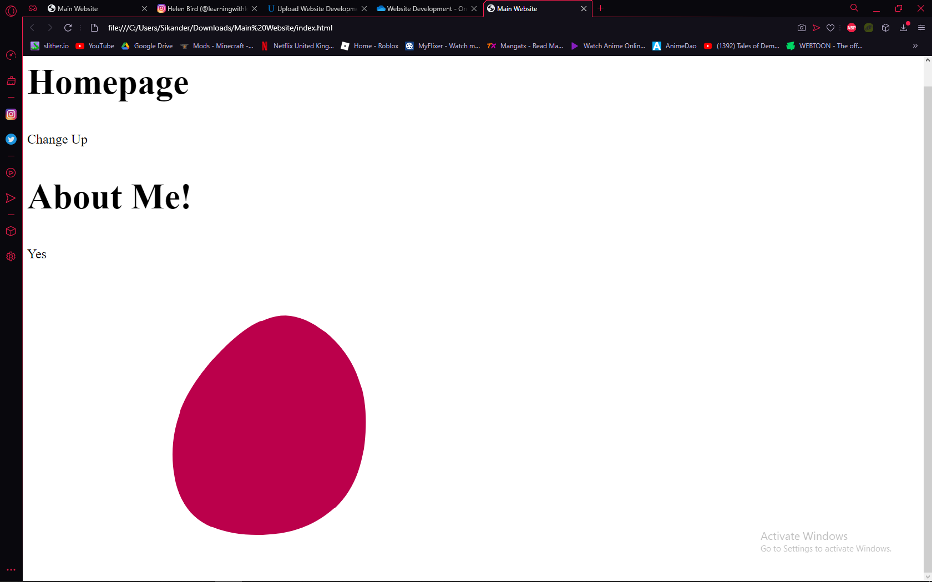

## Second Error

I’ve been trying to do my Email Validation Check but for some reason, the .js file is being imported into the main file and is being used but the actual functions do not activate when clicking submit button.

### Old Code :

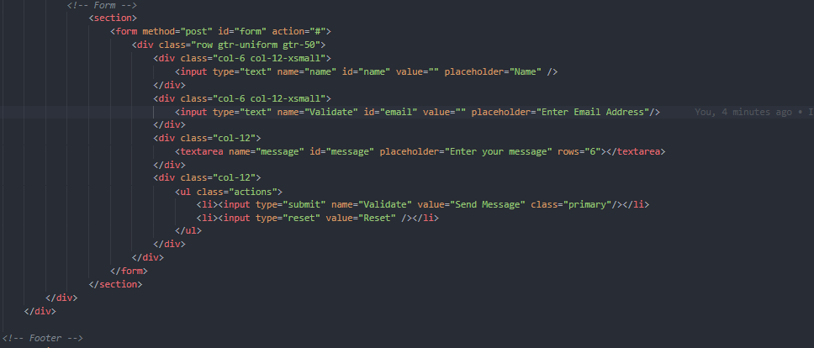

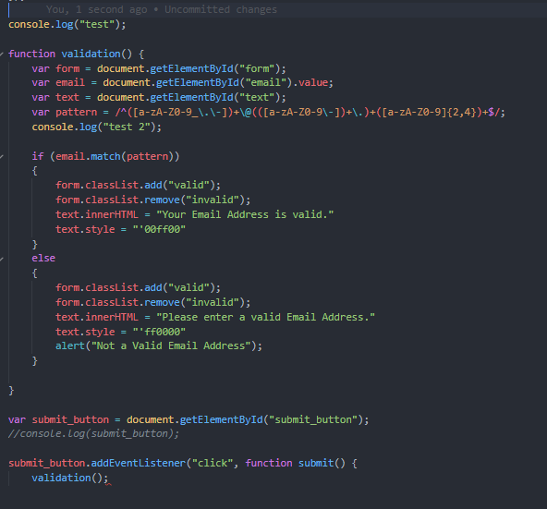

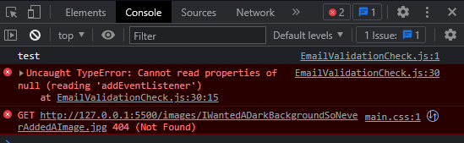

The email Validation is unable to find the event even though the event is defined, asking the button to be clicked. This doesn’t allow the code to work and validate the email.

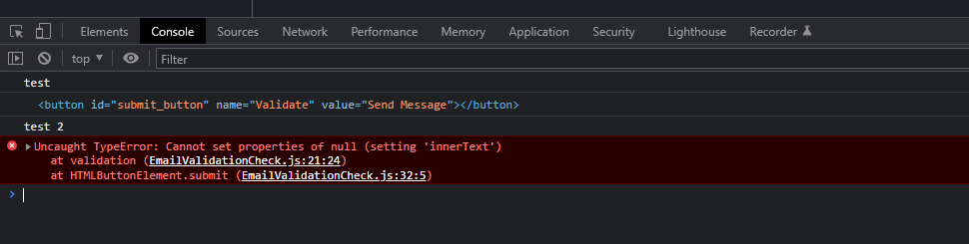

The function works but now displays many errors, supposedly saying the innerText is incorrect. When the function should work but doesn’t.

### New Code :

So I had to change the majority of the function code inorder to get it to work. This allowed the code to work because I had one to many error’ing pieces of code within this one file.

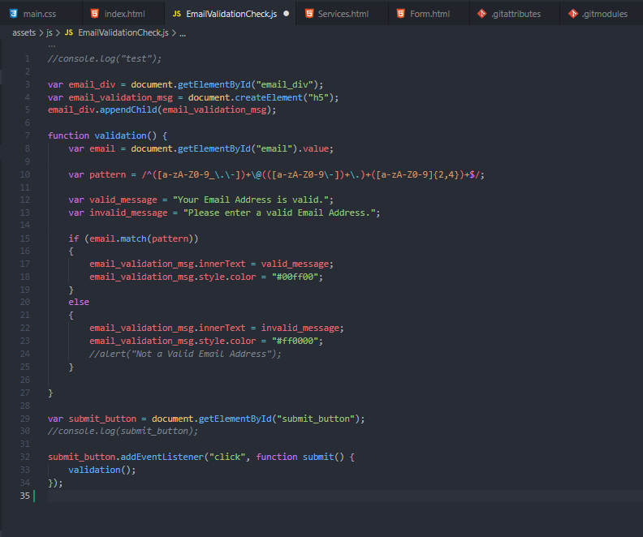

This change had made the code work, allowing me to check whether the user is inputting a correct Email Address.

### Error 3

The form page would load another frame, tab, window and then the code would break because there was an empty action tag that would load another frame. This would break the code since I was unable to go back to the previous page.

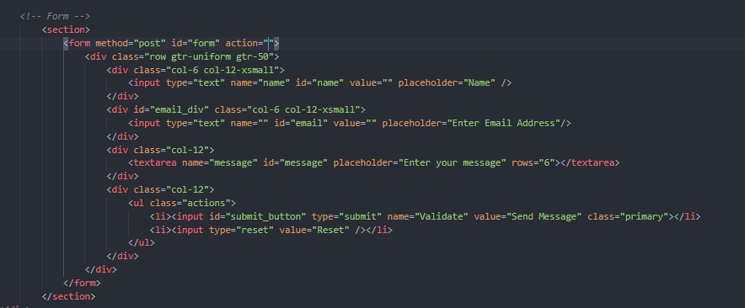

I fixed the issue by having “javascript:validate()” inside the action tag such as this. This ignored the frame opening and sent the actual message of having an incorrect/invalid or correct/valid email address display.

<form method="post" id="form" action="javascript:validate()">

